HIDDEN HISTORIES 2022
Trovare le parole / Finding the words
curated by
Sara Alberani and Marta Federici
with Valerio Del Baglivo

Books are bodies (they can be dismembered)
exhibition and public programme by Dora Garcia

7 September 2022
6.30 pm - performance by Dora García
6.30-8.30 pm - exhibition opening
The exhibition can be visited from Monday to Friday, from 10 am to 2 pm.
The entrance is free.
Biblioteca Casanatense - Salone Monumentale
Via di Sant’Ignazio 52, Rome

21 September 2022, 6 pm - reading group with Dora García
Real Academia de España en Roma, Piazza di S. Pietro in Montorio, 3, Rome

28 September 2022, 6.30 pm - performance by Dora García, with the participation of Maria Elena Fantoni and Brianda Carreras
Biblioteca Casanatense, Sala di Lettura
Via di Sant’Ignazio 52, Rome

11 September 2022, 5 pm
Stati Transitivi (Transitive States): Talk with Renata Carvalho, Antonia Caruso, Adelita Husney-Bei, Sara Alberani and Marta Federici (LOCALES), Matteo Lucchetti (Museo delle Civiltà) and Marcia Leite, in collaboration with Short Theatre
Mattatoio - Tettoia
Piazza Orazio Giustiniani, 4 - Rome

12-14 September 2022
A Collection in Turmoil. Workshop with Adelita Husni-Bey
Museo delle Civiltà
Piazza Guglielmo Marconi, 14 - EUR Rome
event by reservation only
From September 7th to 28th, the second part of the Hidden Histories 2022 program takes off with new projects by artists Dora Garcia and Adelita Husni-Bey. Curated by Sara Alberani and Marta Federici, with Valerio Del Baglivo, the project is designed from 2020 as a platform for site-specific research and artistic production and aims to critically re-discuss the city's historical-artistic legacy, adopting approaches and methods of decolonial thinking.
In this third edition, the focus remains on the public space, a dimension that in Rome is closely connected to the notions of heritage, preservation, restoration, and monumentality, along with its collections, archives and objects that still today are read and valued within a white, patriarchal and heteronormative canon.
The subtitle of Hidden Histories 2022 Trovare le parole / Finding the words takes its cue from an expression by feminist theorist Sara Ahmed in her book Living a Feminist Life (Duke University Press Books, 2016), and focuses on the linguistic dimension as a fundamental space in which to act and declare what is not seen and recognized within society as violent, racist, and sexist. As stated by Ahmed, finding words means naming the problems we are confronted with, "allowing something to acquire a social and physical density by gathering up what otherwise remain scattered experiences".
In the words of curators Sara Alberani and Marta Federici, "Hidden Histories 2022 acts through the practices and discourses of the artists involved, who open paths of reappropriation and re-signification of places in the city from which communities have been removed. In different ways and manners, the interventions detect and analyze processes of invisibilization and track down marginalized stories and voices in order to bring them out into the public space, as is the case in Iván Argote's work with the children of the Esquilino neighborhood; other interventions critically reread common expressions, such as Autumn Knight's "dolce far niente," (the sweetness of doing nothing) whose performance at Palazzo Altemps speaks to us about racialized bodies and survival strategies. Dora García, on the other hand, gives voice to books and texts that have been subject to censorship throughout history, through a public program that stems from a study of the archives of the Casanatense Library. Finally, Adelita Husni-Bey offers a collective workshop that starts with an analysis of the collections of the former Museo Coloniale, which have become part of the collections of the Museo delle Civiltà di Roma which are currently undergoing a series of research activities.
All events are open to all and free of charge. Access is subject to availability

THE PROGRAM - PART ONE
In the context of the first part of the program, on June 07 Iván Argote (CO) presented for Hidden Histories the long-running project Activissimə, carried out in the form of a protest workshop for girls and boys ages 4 to 9, aimed at developing critical thinking through language games and playful demonstrations.
In its activation in Rome, the workshop involved a group of girls and boys from the after-school activities of the Associazione Genitori Scuola Di Donato, a reality that constitutes a fundamental point of reference in the Esquilino neighborhood thanks to the initiatives that encourage and consolidate relationships and exchanges among the many communities of different cultural backgrounds that inhabit the area. The children walked through the streets of Esquilino on the afternoon of June 07, starting from the Di Donato school until they reached the gardens of Piazza Vittorio, for a collective moment of protest accessible to all.
The event was held in collaboration with Associazione Genitori Scuola Di Donato and Villa Medici - Accademia di Francia a Roma.

On July 19, artist Autumn Knight (USA) proposed the site-specific performance Church of Nothing, Theatre of Nothing inside Palazzo Altemps, one of the sites of the Museo Nazionale Romano. The work unfolded in two different areas of Palazzo Altemps: the Church of Sant'Aniceto and the Theatre – both spaces linked to a time of leisure, and ritual detached from daily laborious activities. Knight critically explored the Italian concept of "dolce far niente" (the sweetness of doing nothing) using body, text and sound as means to explore the political meanings and creative potential of "doing nothing".
The event was organized in collaboration with American Academy in Rome and Museo Nazionale Romano.

THE PROGRAM - PART TWO
The second part of the program starts on September 7 with artist Dora García's new work, Books are Bodies (they can be dismembered), designed for the spaces of the Biblioteca Casanatense in Rome.
The project consists of an exhibition, two performances as well as a reading group, and develops a reflection on the notion of censorship and its implications. Garcia worked on a selection of censored, erased, dismembered books from the collection of the Biblioteca Casanatense: tracing their connections and reconstructing their silenced histories, the artist analyzed the potential for subversion that was recognized within the texts.
The installation at the Monumental Hall of the Biblioteca Casanetense focuses specifically on the volume Apocalypsis Nova, written by Beato Amadeo da Silva at the site of the apostle Peter's martyrdom, the Tempietto del Bramante, now part of the Real Academia de España en Roma. The text, which will be shown in some manuscript copies, bore witness to a frightening change of the times and was censured for its prophetic visions. Taking inspiration from the events related to this work born in the late 15th century, García puts together a complex narrative, made of bodies and voices, people and books, that winds through various places in the city, linking the spaces of the Casanatense library to those of the Spanish Academy.
The program includes:
. Sept. 7 | 6.30-8.30 pm – Opening of the installation at the Monumental Hall of the Biblioteca Casanatense and performance-reading by Dora García.
A series of showcases set up in the Salone Monumentale of the Biblioteca Casanatense will present a selection of ancient volumes that were subject to censorship, part of the library's heritage and chosen by Dora García during her months of study and research. On the occasion of the opening of the exhibition, García will read and comment on excerpts from these texts.
. Sept. 21 | 6 pm – Reading group at the Tempietto del Bramante, Real Academia de España en Roma.
Dora García proposes a session of reading and conversation at the Real Academia de España en Roma, in order to explore the issues raised by the book Apocalypsis Nova by Beato Amadeo da Silva, part of the installation at the Biblioteca Casanatense. The book is presented as a revealed text, that is, one that was born from the transcription of a conversation that took place between Beato Amadeo and the Archangel Gabriel. This mystical encounter is said to have taken place in the crypt where the Apostle Peter is said to have been crucified, where the Tempietto di San Pietro in Montorio stands today. The artist will share excerpts from this text and other related books with the participants, to read and discuss together the interference between mysticism and politics.
.Sept. 28 | 6.30 pm - Performance in the Reading Room of the Biblioteca Casanatense, with the participation of Brianda Carreras and Maria Elena Fantoni. Finissage of the exhibition at the Salone Monumentale.
For the closing event of the project, performers Brianda Carreras and Maria Elena Fantoni will lead the audience in a "conversation scene": while leafing through and commenting on different books conserved on the shelves of the Reading Room of the Biblioteca Casanatense, the two women will develop a dialogue in relation to time, history and contemporaneity.
The project is made possible thanks to the support and with the collaboration of Real Academia de España en Roma, in collaboration with Biblioteca Casanatense.

In the month of September, Hidden Histories also hosts Italian-Libyan artist Adelita Husni-Bey, who leads the workshop A Collection in Turmoil from September 12 to 14, in the spaces of the Museo delle Civiltà, EUR.
Hidden Histories renews its collaboration with the Museo dell Civiltà for the third consecutive year and, through the activation of collective learning moments, reflects again on the histories and untold stories of this complex institution, which includes within it the collections already belonging to five different national museums.
A Collection in Turmoil specifically fits into the context of a new process of progressive and radical revision activated by the museum, which aims to question – and to try to rewrite – its history, its institutional ideology, and its research and pedagogical methodologies. Creating a space for collective research, study, discussion and dialogue, the workshop relates to this process of identity transition of the institution, and intends to activate a reflection on the history, objects, nomenclature systems and taxonomies of the collections of colonial provenance that today are part of the Museo delle Civiltà.
As stated by the artist, if «the transitive process is by its nature collective and not private, since it deals with thoughts and relationships born on shared grounds» and «if identity necessarily produces subaltern subjects, can we imagine a building able to collect public memories in a perpetual state of dis-identification?». Starting from this question, by listening to and integrating the experiences of re-semantization lived by people and entities in states of transition between genders (transgender), countries (migration), and former colonies (liberation), A Collection in Turmoil will try to articulate a logistics of change able to innovate methods and processes by which to rethink a transitional identity of the museum and its collections.

Preceding the workshop, on Sunday September 11 at 5 pm, the talk Transitive States, curated in collaboration with Short Theater Festival, will be held at the Mattatoio di Roma. The talk will put artists Adelita Husni-Bey and Renata Carvalho – the latter featured in the Short Theatre programme – in dialogue with editor, writer and trans-feminist activist Antonia Caruso. Moving from Carvalho's work on the travesti body to Husni-Bey's research on the collection of the former colonial museum, preserved in the Museo delle Civiltà of Rome, the discussion will investigate the conservative nature of the act of naming and the impact of a colonized semantic universe, delving into the concepts of inheritance, identity and embodied experience and their relationship to each other. The idea of a "transitive" state, of continuous transformation, will be explored in relation to both physical and institutional subjects. In addition to the three mentioned speakers, Hidden Histories 2022 curators Sara Alberani and Marta Federici, Museo delle Civiltà curator Matteo Lucchetti and trans-feminist activist from the Associazione Libellula Marcia Leite will take part in the dialogue.

The workshop A Collection in Turmoil is co-produced by the Museo delle Civiltà as part of the European project Taking Care - Ethnographic and World Cultures Museums as Spaces
of Care, co-funded by the Creative Europe programme of the European Union.

Requests for registration can be sent to. hiddenhistories.rome@gmail.com.

Partners and supporter of the three-year program of Hidden Histories: Accademia Tedesca Roma Villa Massimo, American Academy in Rome, Biblioteca Casanatense, BSR British School at Rome, Centro Cultural de España en Lima, Circolo Scandinavo, Fondazione Romaeuropa, IILA - Organizzazione Internazionale Latino-americana, MAXXI - Museo Nazionale delle arti del XXI secolo, Museo delle Civiltà, Taking Care - Ethnographic and World Cultures Museums as Spaces of Care, Museo Nazionale Romano, NABA, Nuova Accademia di Belle Arti, Real Academia de España en Roma, Villa Medici - Accademia di Francia a Roma, Università degli Studi Roma Tre.
_________________________________________________________________________
Hidden Histories is a project curated by Sara Alberani, Marta Federici and Valerio Del Baglivo, all members of the LOCALES collective.
LOCALES is a curatorial platform founded in Rome that aims to inspire a reflection on the public sphere through artistic practices. Through a series of site-specific programs involving commissions of new artworks, explorations of public spaces, educational activities, and performances, LOCALES addresses the complexity of contemporary urgencies starting from the political and social history of symbolic places in the city and their local communities.

Iván Argote is a Colombian artist and film director based in Paris. Through his sculptures, installations, films and interventions, he questions our relation with others, with power structures and belief systems. He develops strategies based on tenderness, affect and humour through which he generates critical approaches to dominant historical narratives. In his interventions on monuments, large-scale ephemeral and permanent public artworks, Iván Argote proposes new symbolic and political uses of public space. Works by the artist are included in the permanent collections of numerous prestigious institutions worldwide, including the Guggenheim Museum (New York, US) ; Centre Pompidou (Paris, France); ASU Art Museum (Phoenix, US); Cisneros Fontanals Art Foundation (Miami, US) ; Colección de Arte del Banco de la República (Bogotá, Colombia); Kadist (San Francisco, US) ; MACBA (Barcelona, Spain). Iván Argote was recently nominated to the Prix Marcel Duchamp in Paris. As part of this, he will present an exhibition at Centre Pompidou.

Autumn Knight is a New York-based interdisciplinary artist working with performance, installation, video and text. Knight’s video and performance work have been viewed within several institutions including the Whitney Museum of American Art, The Kitchen, DiverseWorks Artspace, Art League Houston, Project Row Houses, Blaffer Art Museum, Crystal Bridges Museum, Skowhegan Space (NY), The New Museum, The Contemporary Art Museum Houston, Optica (Montreal, Canada), The Poetry Project (NY) and Krannart Art Museum (IL), The Institute for Contemporary Art (VCU), Human Resources Los Angeles (HRLA) and Akademie der Kunste, (Berlin). Knight is the recipient of the 2021-2022 Nancy B. Negley Rome Prize in Visual Arts and a 2022-2023 Guggenheim Fellowship.

Dora García is an artist, teacher and researcher; lives and works in Oslo. Her work is largely performative and deals with issues related to community and individuality in contemporary society, exploring the political potential of marginal positions, paying homage to eccentric characters and antiheroes. These eccentric characters have often been the centre of her film projects, such as The Deviant Majority (2010), The Joycean Society (2013) and Segunda Vez (2018). The oeuvre of Dora García folds up into writing, film, installation, and performance, and is centered around stories which she organises and stages, conjuring situations designed to engage the visitor and trigger unique, introspective experiences. As an artist, Dora García has participated in numerous international art exhibitions, including Münster Sculpture Projects (2007), Venice Biennial (2011, 2013, 2015), Sydney Biennial (2008) São Paulo Biennial (2010), dOCUMENTA 13 (2012) Gwangju Biennial (2016), osloBiennalen, Art Encounters Timisoara (Romania), and AICHI Triennale, Japan (2019). In 2021 she developed projects in Fotogalleriet Oslo, Netwerk Aalst (B) and the festival Colomboscope, Sri Lanka.

Adelita Husni-Bey is an artist and an expert in pedagogy, interested in topics ranging from anarcho-collectivism to theater, from jurisprudence to urban development studies. She is also involved in organizing workshops, producing publications, curating radio broadcasts, archives, and exhibitions, using non-competitive pedagogical models through the framework of contemporary art. She has participated in Work it Out! Aalborg Museum, 2021 (...). She is a Fellow at the Vera List Center for Art and Politics 2020-2022 where she developed These Conditions, 2022 at Brooklyn Army Terminal, New York, a hybrid space between exhibition venue, film set, and pedagogical space.

Hidden Histories is organized by Mariana Trench Associazione Culturale, promoted by Roma Capitale - Assessorato alla Cultura, is the winner of the Public Notice "Estate Romana 2020 - 2021 - 2022", curated by the Department of Cultural Activities and is realized in collaboration with SIAE.
Sponsored by

In collaboration with

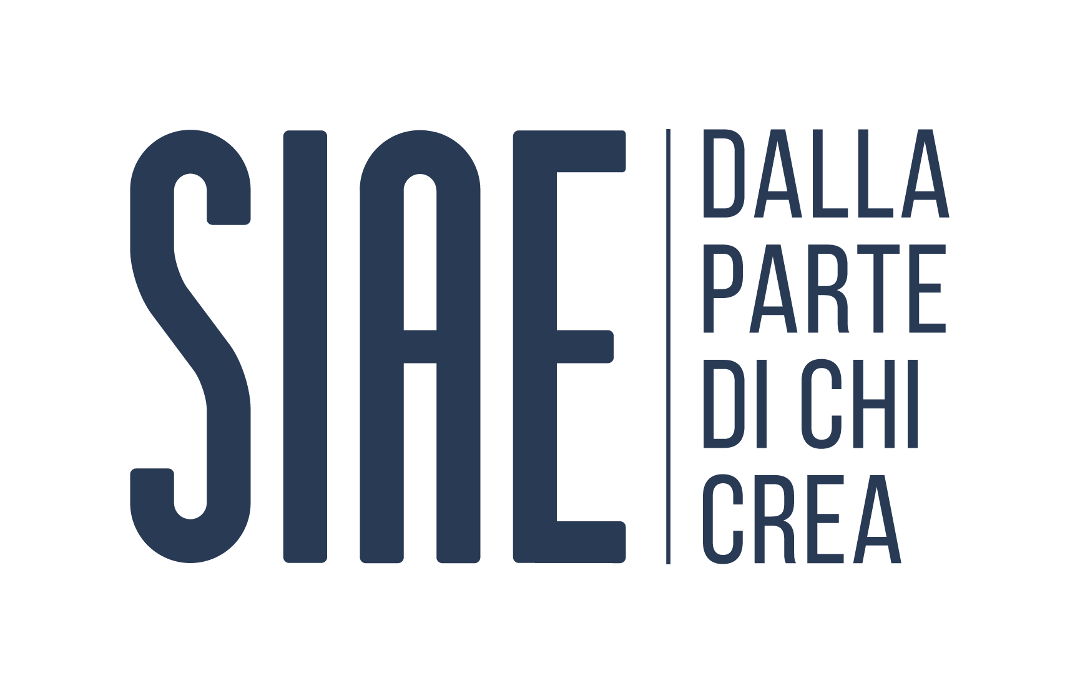

Supported by
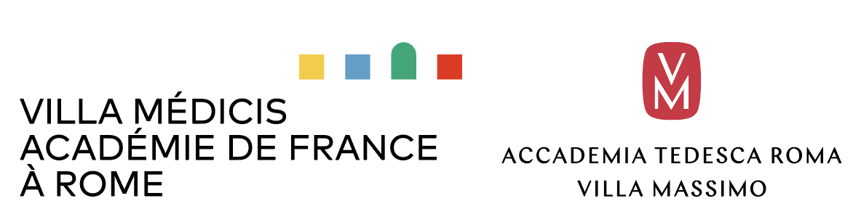

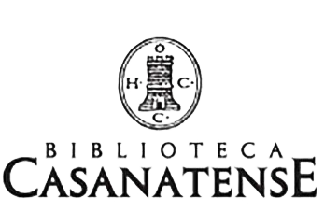
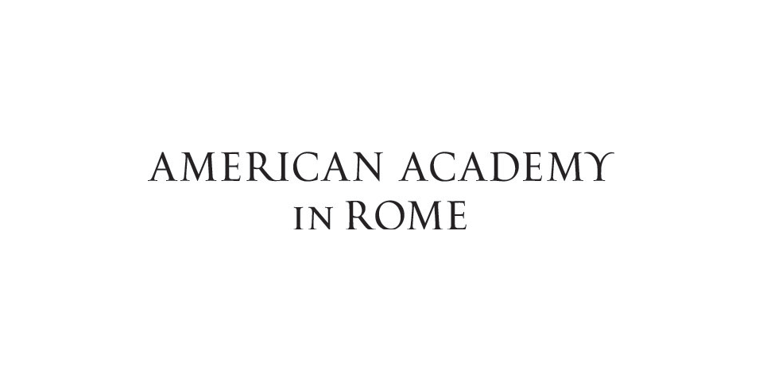
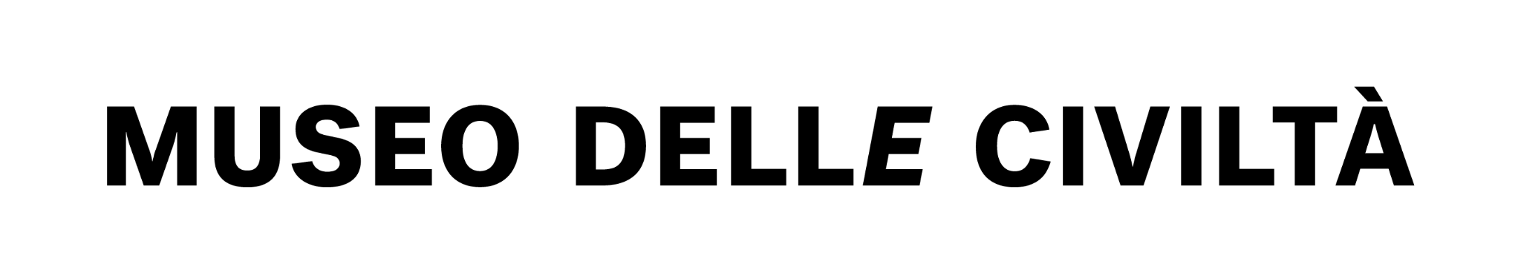
Partner
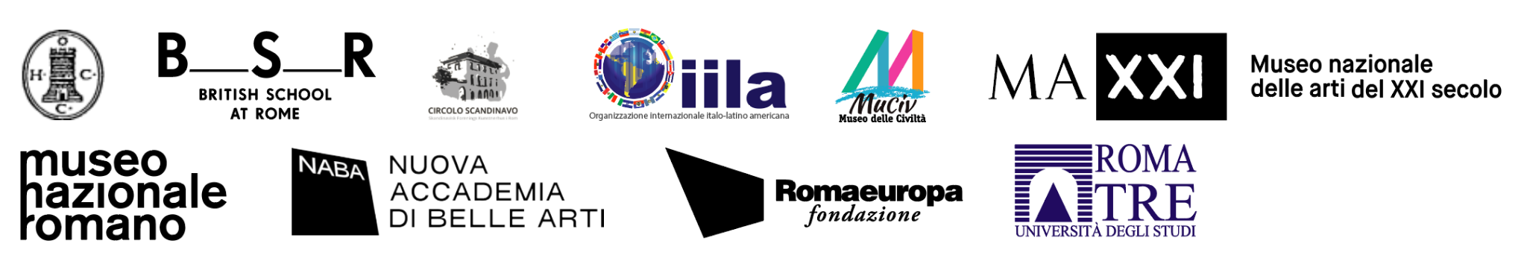

Info and reservations:
www.localesproject.org - Locales • Instagram - Locales - Facebook
hiddenhistories.rome@gmail.com

Press Office and media UC studio - press@ucstudio.it
Chiara Ciucci Giuliani chiara@ucstudio.it - mob + 3929173661
Roberta Pucci roberta@ucstudio.it - mob + 3408174090

